Each community page should have this info:

* Percentage of population
* Regions of origin/birthplaces (cities and administrative regions, e.g. Delaware, Maharashtra, Al-Hasa, Sverdlovsk, etc.)
* Traditions
* Historical summary
  + Example (for American): Modern American culture is, as they say, born from a melting pot. Americans trace their cultural heritage to English colonial settlers on the East Coast, who interacted with native Americans, displacing them but still being influenced by their culture. After gaining independence from Britain, the late 19th century immense numbers of European immigrants and the emancipation of slaves led to internal migration, on top of the settlement of the Wild West and the incorporation of Spanish-speaking communities, established new influences on American culture. The United States came out of both World Wars as a cultural hegemon, with its famous film industry and advertising sector exerting influence over the whole world. This is only the tip of the iceberg as to the myriad influences on American culture, which proudly mixes traditions from all over the world.

Gathered info:

**Saudi**

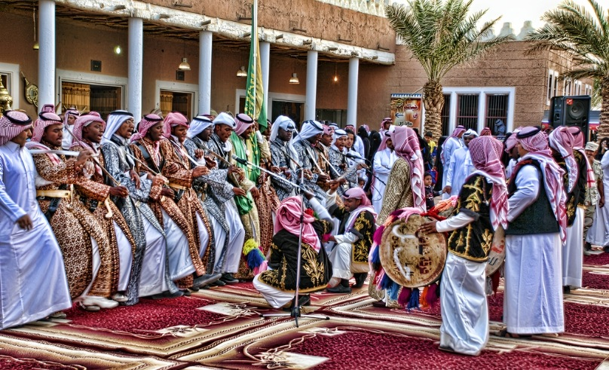

Saudi Arabia has a long history of Arabic culture and heritage to draw on. It has particularly been influenced by being Islam's birthplace, including the holy cities of Mecca and Medina, situating it at the center of the Islamic world and receiving millions of pilgrims over the centuries. The culture of Saudi Arabia maintains ancient traditions, mixed with influences from abroad and evolving with modern times.

* Regional differences exist such as accents or festivals
* Past-times: Backgammon, fishing and football
* Dates: Islamic dates and Gargee’an
* Customs: Treating people with respect
* Clothing: Thawb and the Bisht (which has variations)
* Food: Maqlooba, Gaimat, and Ritab
* Art: Poetry
* Sword Dance
* Locations: Kaaba, Tarout Castle
* Figures: The Prophet Muhammad, Ibn Saud

**Pakistani**

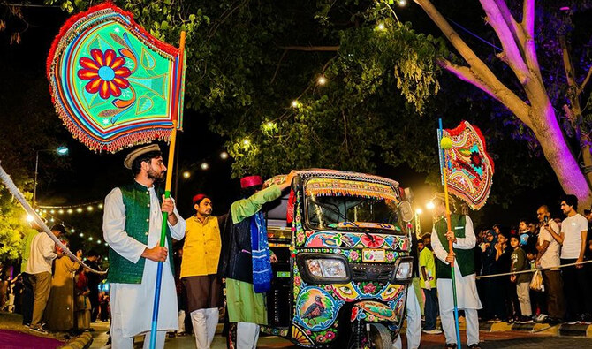

* Some regional identity but still strong identification with the country as a whole
* Sports: Cricket and field hockey (national sport). Cricket is extremely popular.
* Past-times: Ludo (very popular)
* Dates: Islamic dates, Independence Day, (Aug 14, a very communal celebration which brings together neighborhoods and even entire cities), Military Day (March 23)
* Customs: Hospitality, kindness and respecting elders are very important
* Clothing: Shalwar Kameez
* Food: Halwa Puri, Karachi Chicken, Butter Chicken, Naan, Roti, Paratha
* Drinks: Lass (yogurt-like milkshake often modified with the addition of other flavors), Chai
* Desserts: Burfi, Gulab Jamun
* Famous figures: Muhammad Ali Jinnah and Muhammad Iqbal
* History summary: Pakistan for a long period of time was heavily connected with the rest of the Indian Subcontinent. Pakistan was eventually colonized by the British however after WW2 the process of decolonization began during which modern India and Pakistan were the same country. Conflict arose between Muslims and Hindus leading to Pakistan’s independence in 1947, though tensions with India continue to this very day. Bangladesh was initially part of Pakistan but separated in 1971.

**Algerian**

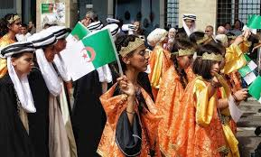

Situated in Northwest Africa, Algeria predominately speaks Arabic but maintains many traditions from the native Berbers. Islam has greatly influenced its culture and Islamic virtues are held in great importance. Its colonial and conflict-ridden past continues to have effects on the country today, but the country has begun to shake the yoke off, staying on the path of development and stability.

* Some regional difference exists with different foods and clothing
* Past-times: Playing cards, checkers, chess games, horse racing (called fantasia) and rifle shooting
* Dates: Independence Day (July 5) and Revolution Day (November 1)
* Customs: Islamic virtues are very important
* Food: Couscous, Chakhchouka, Borek, Kesra
* Art: Ceramics, carpets, leather, glass work, silverwork
* Dance: Chaoui Dance
* Important/famous locations: Beni Hammad, Tassili n’Ajjer, M’Zab Valley, Djémila, Timgad, Tipasa, Algiers
* Clothing: Karakou
* Figures: Moufdi Zakaria, Mohammed Al Aid, Achour Fenni, Amar Meriech and Azrag Omar

**Indonesian**

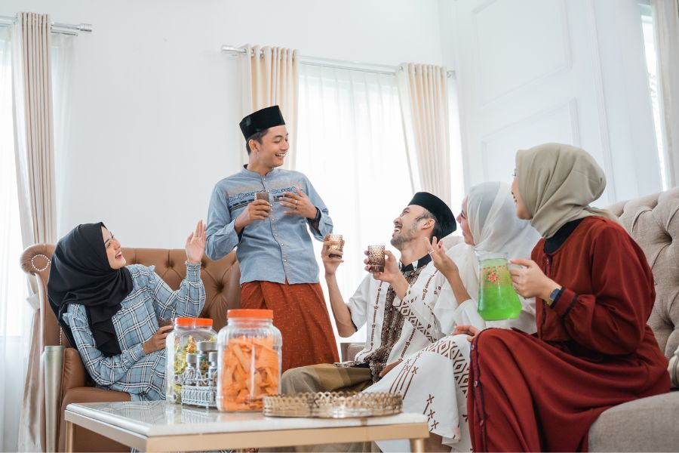

* There is a lot of regional difference in Indonesia and oftentimes people won’t speak the same language, much less eat the same food.
* Past-time: Badminton
* Dates: Islamic dates and Independence Day (August 17)
* Customs: A lot of rituals to show respect for elders, such as bowing the head slightly, taking their hand to your forehead, and sitting beneath them.
* Food: Cireng, hand-pulled noodles, Satay (a lot of chewy foods)
* Art: Batik (a technique for dyeing and decorating cloth)
* Clothing: Batik
* History: Indonesia was once colonized by the Dutch and was occupied by Japan during WW2. After the war they fought a war of independence against the Dutch and won.

**Filipino**

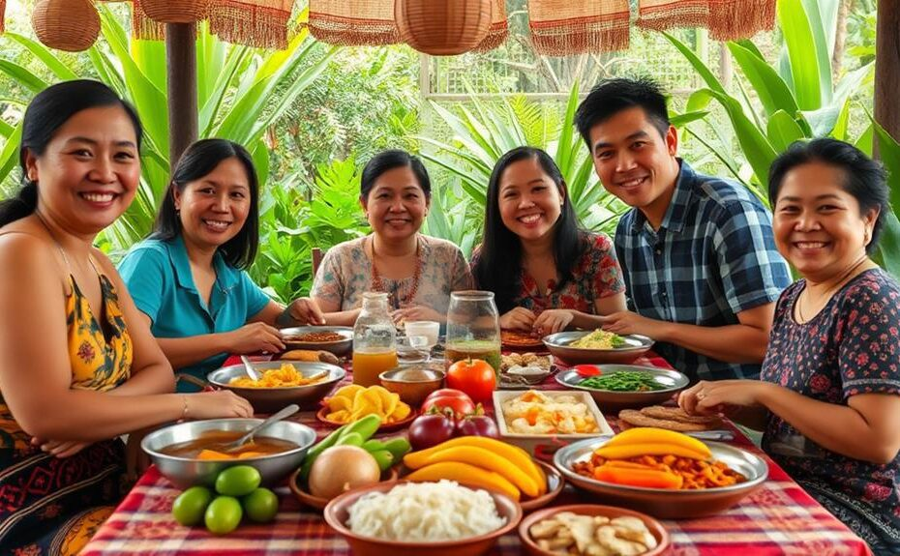

The Philippines is a country of notable size with a large population and is very linguistically diverse. It similarly has a wide variety of influences, though the country speaks Austronesian languages, it was at various times influenced by Indian, Chinese, Islamic, and Christian cultures. However, significant unity and common tradition derive from the majority of the population following Catholicism and the struggle of the country to achieve independence from Spain and the U.S. In modern times economic development has furthered cultural consolidation and the Philippines exists as a rich and distinct cultural tapestry.

* Regional culture is important. Respondent identified with the dialect Bicolano.
* Street food is prominent
* Dates: “Debuts” for girls who turn 16 years old and a celebration for men when they turn 21 or 23. This is usually to propose them to society as “singles”.
* Customs: When greeting an elder you touch their hand to your head
* Food: Rice is eaten with every meal and other foods are usually sweet
* Dance is popular
* Song: Kids sing carols around the neighborhood and people come out to give them spare change
* Location: Mayon Volcano
* Clothing: Barong for men and Filipiniana for women, usually at weddings
* Figures: Jose Rizal Jr.

**Indian**

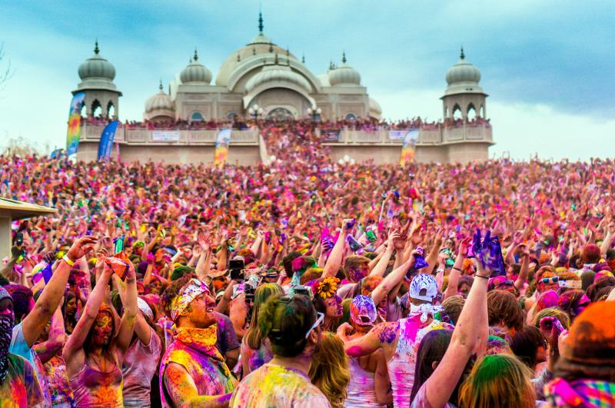

India is a very large and very diverse country, with hundreds of different languages and unique customs across its land. However, some national identity exists, partly due to Hinduism but also because of increasing access to the internet and improving infrastructure paving the way for greater communication between Indians, contributing to a burgeoning national identity.

* Respondent identified more with a regional identity due to them being Christian which is very much a minority in India
* Past-times: Cricket and Carrom
* Customs: Respect is valued
* Food: Chicken Lollipop, Butter Chicken
* Locations: Taj Mahal
* Clothing: Kurtha for men and Saree for women
* Figures: Mahatma Gandhi

**Chinese**

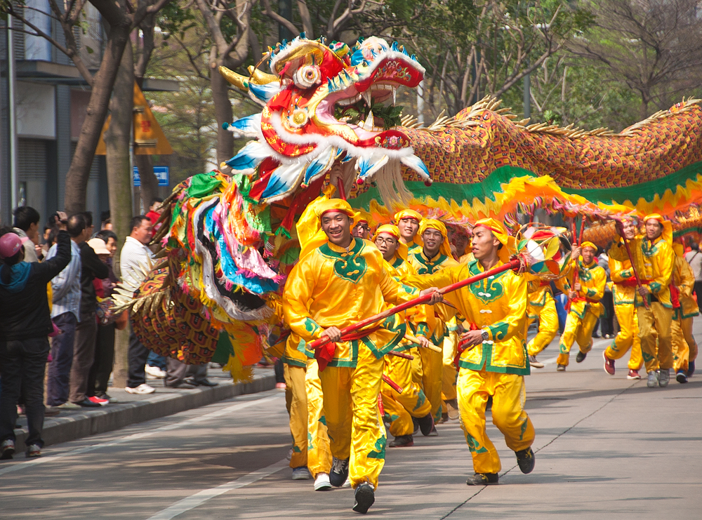

China is a massive country with wide ecological diversity accompanied by large linguistic diversity. However Chinese culture has historically been relatively monolithic, drawing upon a common history, government and social values. Chinese culture has also exercised enormous influence on other countries in East Asia, such as Korea and Japan, and also on the world as a whole.

* Little regional differences
* Past-times: The board games Xiang Qi (basically Chinese chess), Wei Qi (also known as Go), Wu Zi Qi (translates to “five in a row”), Mahjong (popular among the elderly)
* Dates: Chinese New Year, Mid-Autumn Festival, Dragon Boat Festival
* Customs: Respect elders and show love to those that are younger
* Food: Noodles, Hot pot, Dumplings, Bao Zi, rice, meat
* Drinks: Tea, iced tea is also popular
* Art: Poetry and painting
* Locations: Great Wall, Terracotta Army, Tiananmen Square
* History: A very long chain of dynasties that were a mixed bag when it came to rulers. Periods of prosperity and ruin alternated alongside repeated fracturing and reunification. In recent times a Communist revolution occurred ending one such period of disunity and creating the country we know today.